Put English Title Here
Gildong Hong¹⁾·Giltong Hong²⁾·Gilryong Hong^{*3)}
Daehan University¹⁾, Mingook University²⁾, Woori Motor Company³⁾

Key words : Put key words here, Put key words here, Put key words here, Put key words here, Put key words here, Put key words here
* Corresponding author, E-mail: Type corresponding author’s email address here

Put abstract here. Put abstract here. Put abstract here. Put abstract here. Put abstract here. Put abstract here. Put abstract here. Put abstract here. Put abstract here. Put abstract here. Put abstract here. Put abstract here. Put abstract here. Put abstract here. Put abstract here.
Abstracts must be typed on good quality this form with wide margins using MS-Word. The language of the paper is English. Authors should submit an electronic file including PDF file of the KSAE website, www.KSAE.org. This abstracts shall not exceed two page and the key words was written 5 or 6 words.
Put abstract here. Put abstract here. Put abstract here. Put abstract here. Put abstract here. Put abstract here. Put abstract here. Put abstract here. Put abstract here. Put abstract here. Put abstract here. Put abstract here. Put abstract here. Put abstract here. Put abstract here.

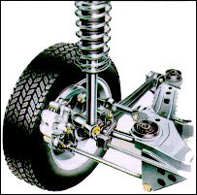
Photo. 1 Type here

(해당 내용은 확인 후 삭제해주세요.)
※ 사사 작성해야 하는 경우
반드시 최종 수정일까지 기재하여 제출!

